|  |  |  |  |  |  |  |
| --- | --- | --- | --- | --- | --- | --- |
| **TITLE OF THE ACTIVITY** | | STI League – E-sports for a Cause | | | | |
| **DATE** | | November 30, 2023 | **VENUE** | STI San Pablo Campus | | |
| **NARRATIVE REPORT** | | | | | | |
| The Club of Programmers conducted and esports tournament in order to earn funds for the upcoming Paskong Paslit. The esports tournament consisted of 3 different games: Mobile Legends, Call of Duty Mobile, and Tekken 7. Registration for these games started on November 30, 2023 up until December 8, 2023. For Mobile Legends and Call of Duty, each team was required to pay a registration fee of 100.00 PHP. In Tekken 7, each player was required to pay a registration fee of 20.00 PHP.  The games Mobile Legends and Call of Duty Mobile was streamed in the official CoPs Facebook page, each with its own set of shoutcasters. Mobile Legends elimination games was held on December 12 2023. Call of Duty elimination games was held on December 13 2023. Elimination games was played by the players in their own homes. The semi-finals and finals for the 2 games were held on December 16, 2023 at STI College San Pablo in rooms 206 and 207. Call of Duty semi-finals and finals was held in the morning. The champion for this tournament was Utopia Gen 3:15. Mobile Legends was held in the afternoon. The champion for this tournament was ICT 101-B. Tekken 7 was held in the afternoon at room 307. The champion for this tournament was Pierce Maverick Sotto. The champions were posted on the CoPs official Facebook page the following day. All these games was officiated and monitored by the Club of Programmers with Jerrel Luna as the head facilitator. No bad blood or any fights happened during the tournament. The students enjoyed playing in the tournament. | | | | | | |
| **PREPARED BY:** | CoPs Officers | | | | **DATE** | January 15, 2024 |

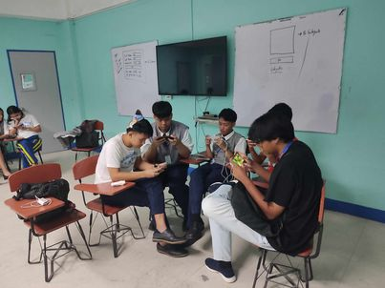**MLBB**

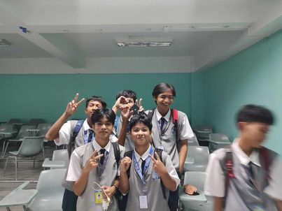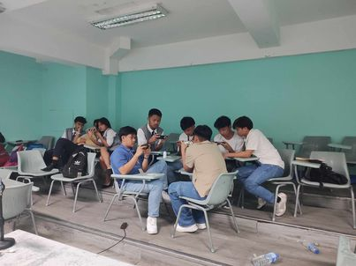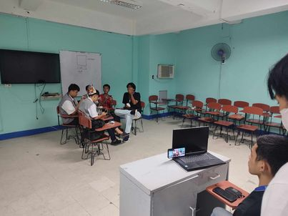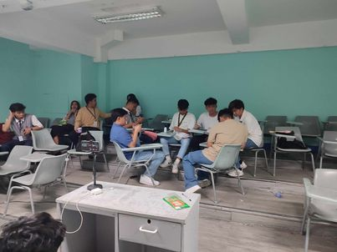

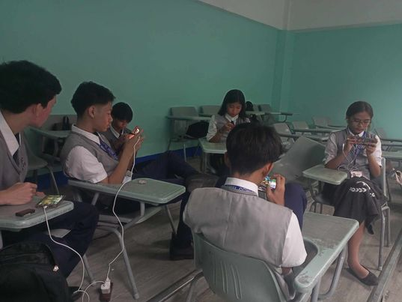**CodM**

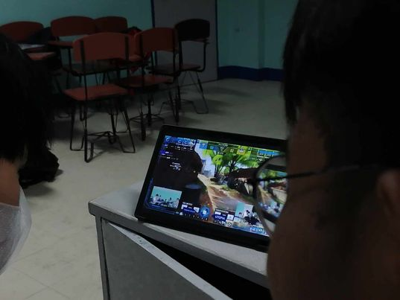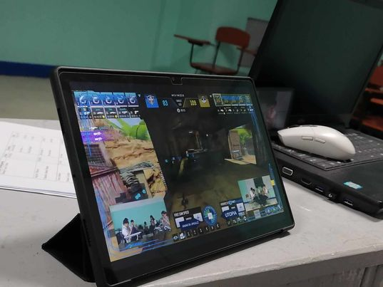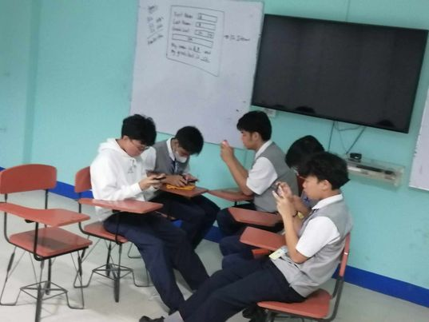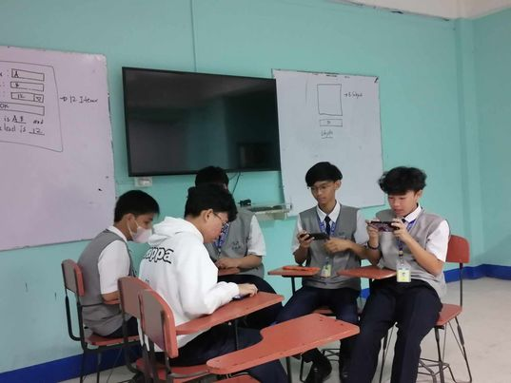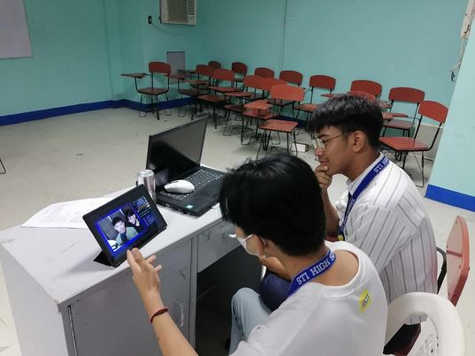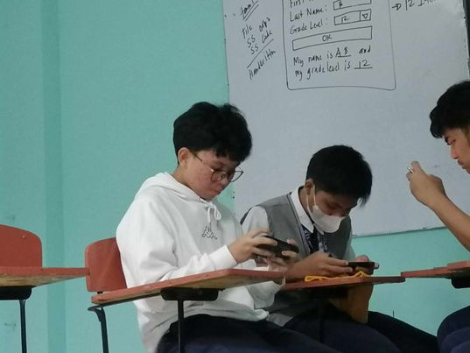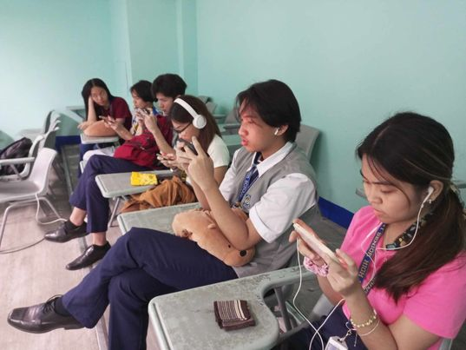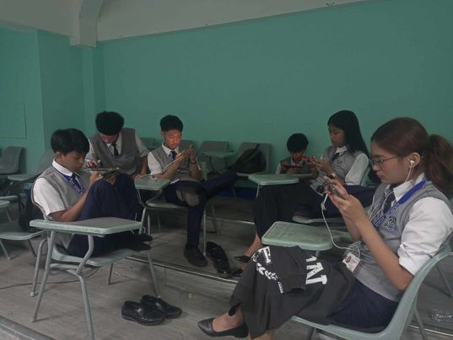

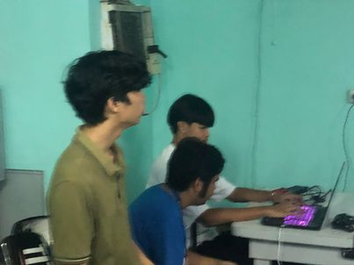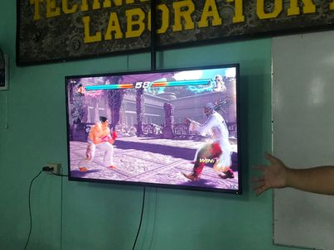**Tekken**

